**Postman-Devnet Setup**

Instructions: You will set up Postman and DevNet login to use for labs this week and beyond. Postman is an API tool used to access and test APIs, and it also assists you in generating API code. Cisco DevNet has some learning exercises, labs, and readings that we will use this semester.

1. To set up a Postman account, launch it from your Linux machine in Netlabs from the application menu (you may have to scroll down to see it):

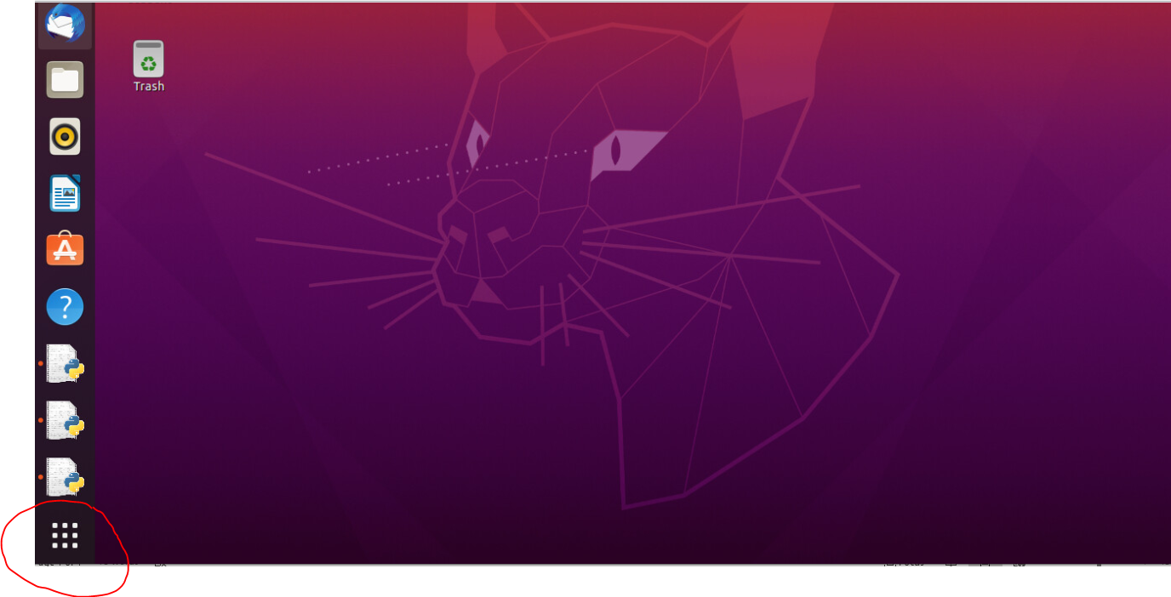

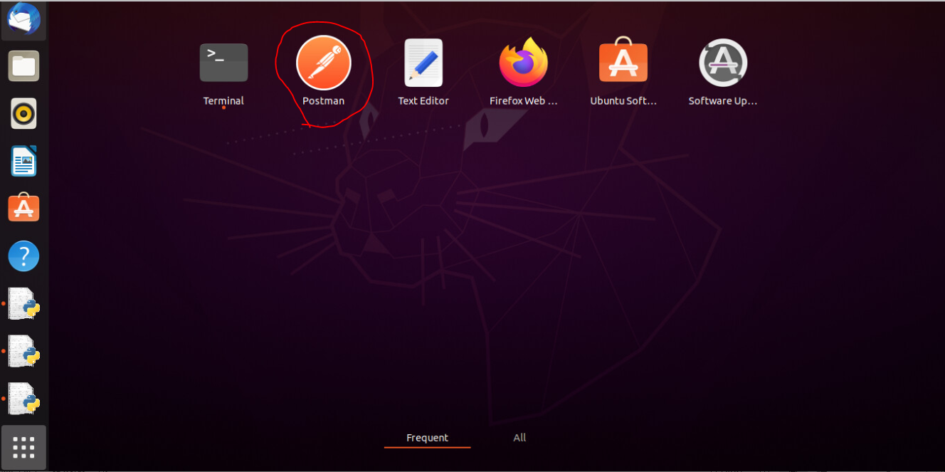

1. Click on the Sign-In button in the upper right corner:

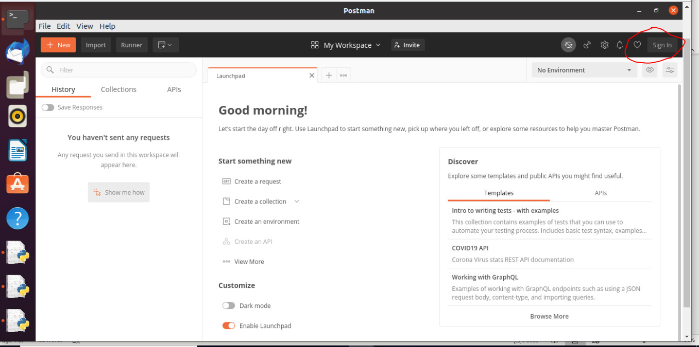

1. Click on Create Account.

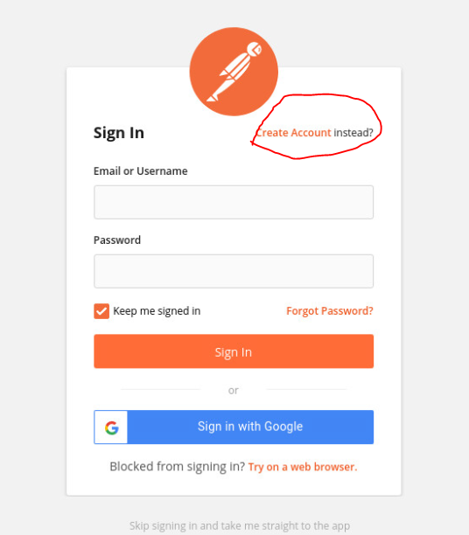

1. When creating your account**, use your Madison College Email address.**
2. Click create a request:

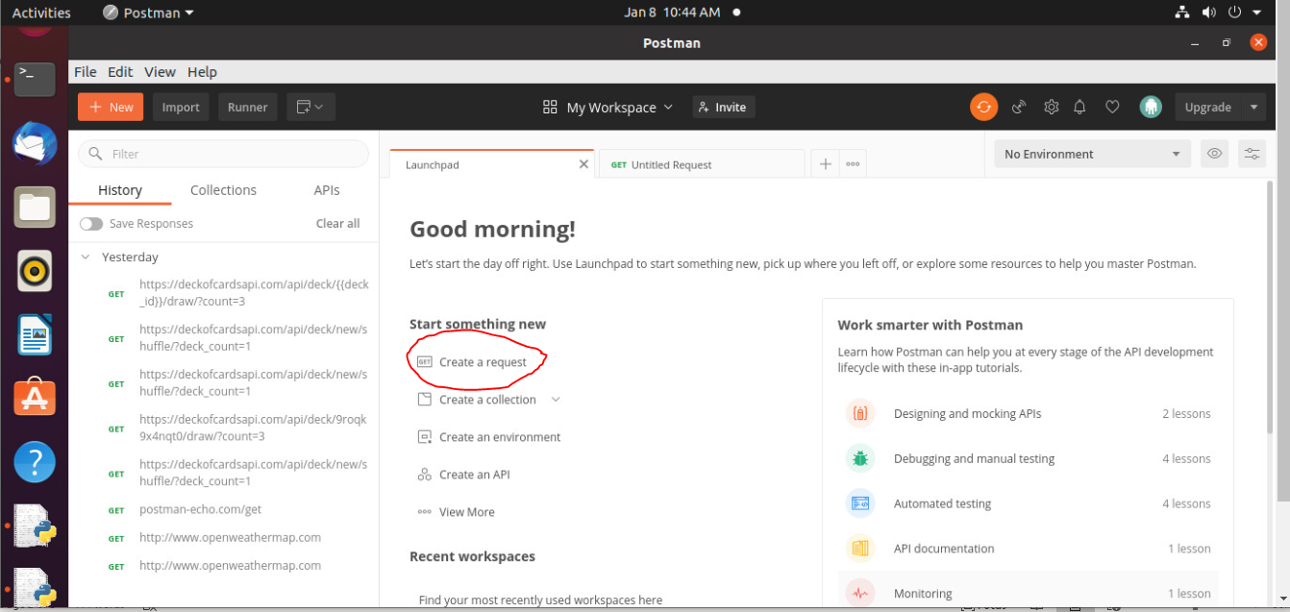

1. **Enter** [**http://www.openweathermap.com**](http://www.openweathermap.com) **in the request field and click send. Note the return values. Note that you can scroll the return value(s) in the return screen. Also, note the status of OK (200). Take a screenshot of your entire Postman screen and submit for this assignment.**

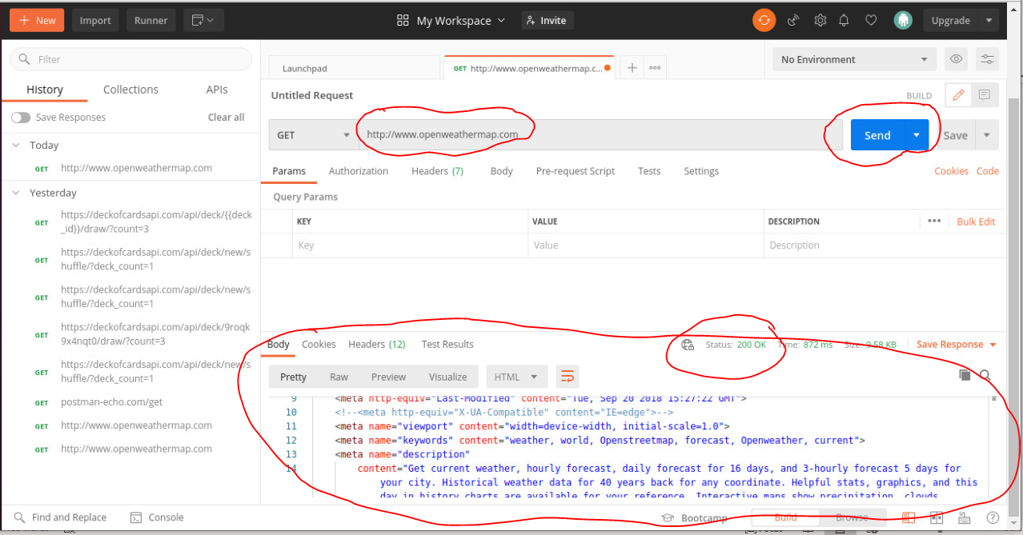

* 1. Log into DevNet using the following URL: [https://developer.cisco.com/learnings/track](https://developer.cisco.com/learning/tracks) Click on Log In in the upper right corner. Then select Login with a Cisco ID. Use your Cisco NetAcad credentials to log in.
  2. Scroll down to Introduction to DevNet:

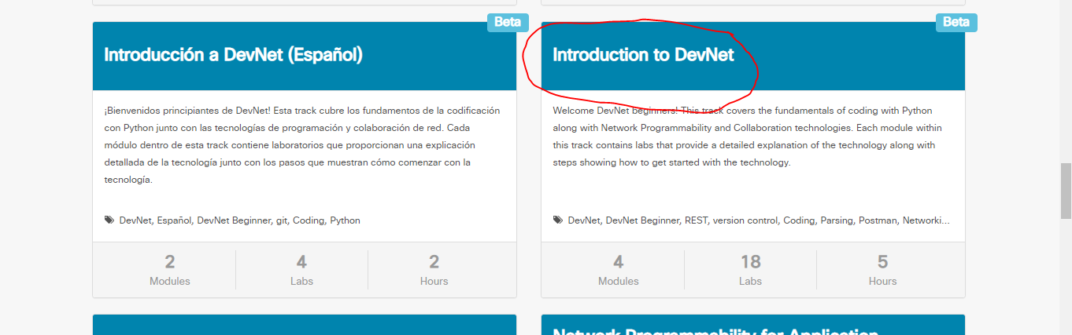

* 1. After reading the NetAcad assignment, you need to perform the labs in the third module, Hands-On Exercise Using Postman to Interact with REST APIs. You can reference the other two modules, if desired. Also note that you can always return to the track screen, above, if you are in a module and want to go back to the screen below. The reading assignment below is necessary for your success in class this week. Failing to do the reading and exercises before the class will set the stage for you to fail the class. You will become lost. Be sure to complete all the readings and labs within them before class. It is advisable that you take good notes for this, noting any questions you have before class.

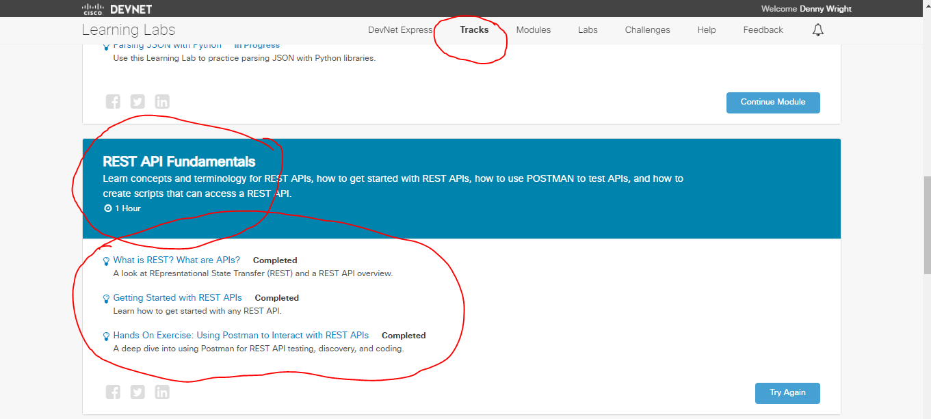

* 1. **In the third section, Hands On Exercise, using Postman, you will need screenshots of the following (see below for examples):**
     1. **The results in JSON (click on the JSON button after sending the request) for the shuffled cards and draw requests in Postman**
     2. **The auto generated Python code for the requests**
     3. **Your Collections for your two deck Requests**

**Request with JSON Results**

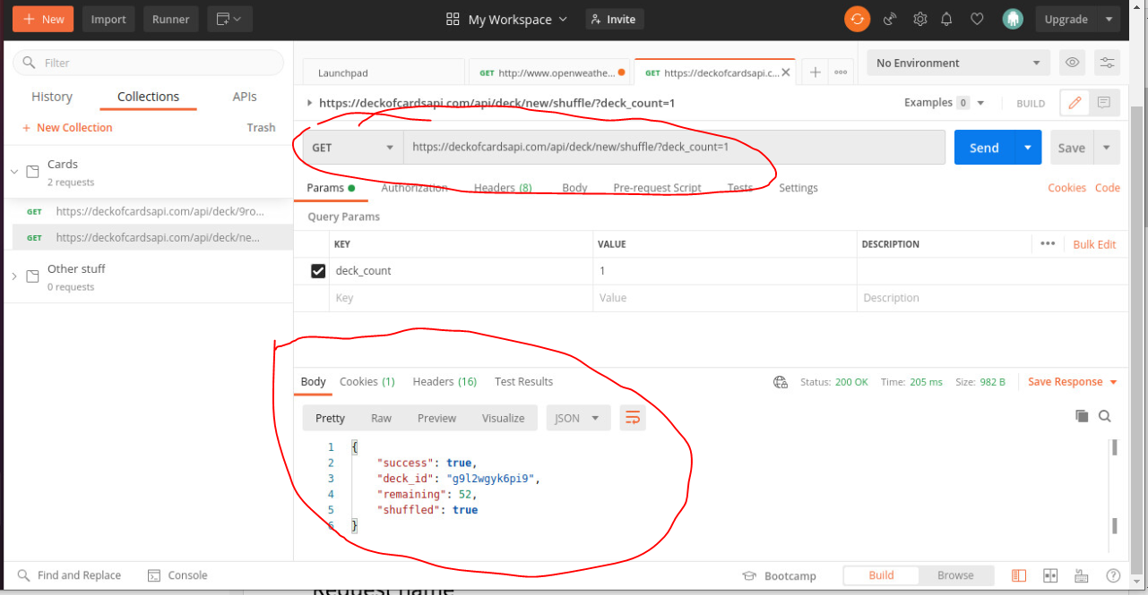

**Request with Generated Python Code**

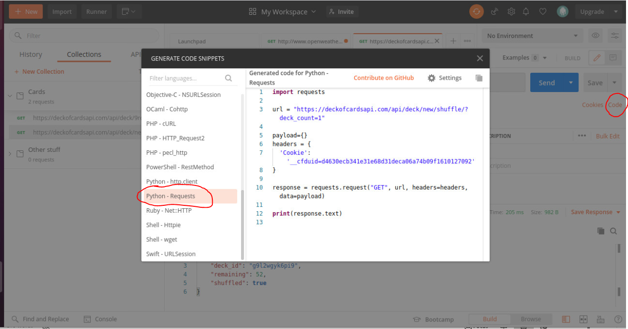

**Collections**

